(For national parks: Link this page from “Things to Do” in the main navigation)

Wildlife Viewing & Photography (apply page title style)
[embed image file name = wildlife_distance_short.png]
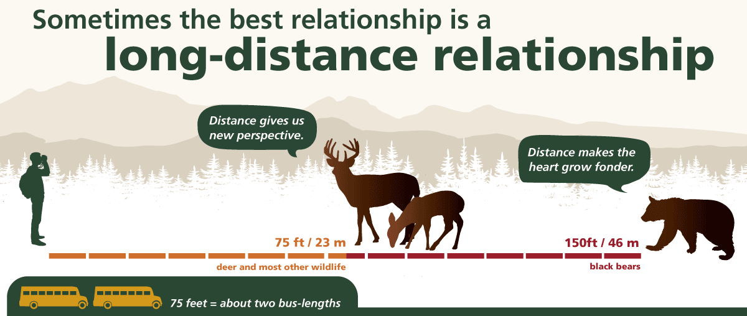

When you spot wildlife, getting a great photo or video from the safe distance is easy if you follow our advice. Although mobile device cameras are convenient, you may want to bring along a camera that has a zoom lens for better zoomed-in photos of wildlife. Keep at least 75 feet or two bus-lengths away from all wildlife in the park, and at least 150 feet or four bus-lengths away from more dangerous animals like black bears.

[for ease of showing the styling of the following section, this part is intentionally left blank in this Word doc]

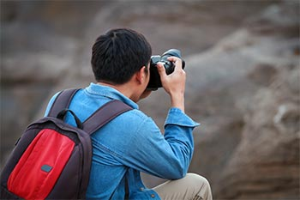
- Time your outing when wildlife is active: dawn or dusk. These times also have some of the best lighting for photos!
[Embed image file name = photo_tips_stabilize.jpg] aligned right of list
- Stay quiet and still. Noise and quick movements can threaten wildlife.
- Look to the edges of the landscape (e.g. where forest trees meet a grassy area).
- Use binoculars, a spotting scope, or a telephoto lens for a safe, close-up view.
- Pull safely and completely off the road, and use your car as an enclosure for viewing and photographing from a distance. Not only do cars provide a layer of protection, they also provide surfaces for stabilizing your camera.
Use your zoom and pull your elbows close to you or rest them on your knee or another stable surface. (apply photo caption styling)
- Use your zoom, and to steady your shot, touch your elbows to your ribcage, or rest your elbows on your knee or another stable surface.
- On your mobile device, you can zoom in by placing your thumb and forefinger together on the screen and then draw them apart just as you do to zoom in on a web page.
- Watch wildlife with your eyes rather than through your viewfinder/screen as you move. It’s easy to miss things in your surroundings that could hurt or trip you when you’re only focused on what you can see on your screen or viewfinder.
- When photographing from the safe distance, skilled photographers suggest lining up the horizon of the landscape along the lower third of your frame and lining up the animal(s) to one of the four intersection points as demonstrated below:
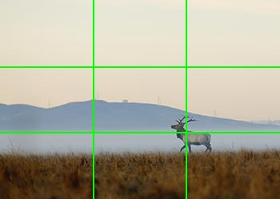
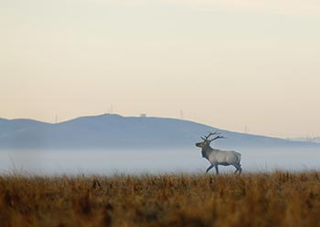

Line up your subject along one of these four imaginary intersections for better-looking wildlife photos from a distance. (apply photo caption styling)
[embed image file name = elk_rule_of_thirds.jpg]
Learn more about what to do when you see wildlife in the park with our wildlife safety tips. (<set to link to the other web page)

